



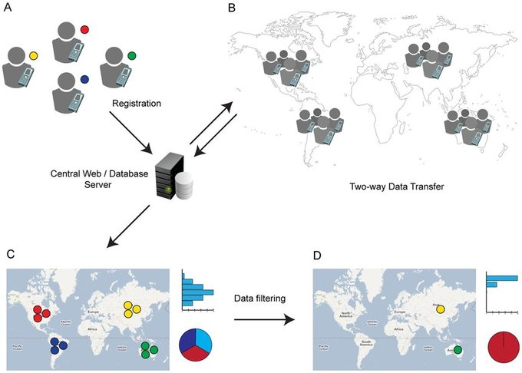
Submitted by:
Geomark Ltd
&
Tiller

Draft Report
On

Package -3:
Socio-Economic and Other Surveys under Preparation of Development Plan for Mirsharai Upazila, Chittagong District: Risk Sensitive Landuse Plan

URBAN DEVELOPMeNT DIRECTORATE (UDD)
Government of the People’s Republic of Bangladesh

TABLE OF CONTENTS
Contents Page no
CHAPTER ONE 1-6
1. Introduction 1
1.1 Background 1
1.2 The executing agency 4
1.3 The Consultant 5
1.4 The project location 6
CHAPTER TWO 7-10
2. Mobilization & Orientation 7
2.1 Consultant’s Organization 9
2.2 Mobilization of The Consultant’s Team 9
2.3 Initial Meetings 10
CHAPTER THREE 10-15
3.1 Overview 11
3.2 Work Plan: 12
3.3 Staffing Schedule 12
3.4 Reconnaissance survey and activity. 14
3.5 Photograph with Stakeholders and Project Area during Reconnaissance Survey. 15
CHAPTER FOUR…………………………………………………………………….16-45
4 Findings:
4.1 Household Characteristics……………………………………………………………16
4.1 Age and sex distribution of Respondents
4.1.1 Age distribution of the Respondents………………………………………...……..17
4.1.2Sex distribution of the Respondents………………………………………...………17
4.1.3 Education Status……………………………………………………………………18
4.1.4 Occupational Status…………………………………………….…………………..18
4.1.5 Marital Status………………………………………………….…………...………19
4.1.6 Family Type……………………………………………………………..………...20
4.1.7 Family Member………………………………………………………..…………..20
4.1.8 Religion…………………………………………………………………………….20
4.2 Characteristics of Autism and Disability
4.2.1 Autism……………………………………………………………………………..21
4.2.2Diability…………………………………………………………………………….21
4.3.1 Income of the Household…………………………………………………………..22
4.3.2 Expenditure of Household…………………………………………………………23
4.3.3 Savings of Household……………………………………………………………..24
4.4 Family Members Staying outside
4.4.1 Distribution of Family Members Staying Outside…………………………………26
4.5 Structure
4.5.1 Structure of House………………………………………………………………….27
4.5.2 Number of Floor of Pucca Structure……………………………………………….27
4.5.3 Construction Year of House………………………………………………………..28
4.5.4 Foundation Type…………………………………………………………………...28
4.5.5 House Soil Type……………………………………………………………………29
4.5.6 Land Price…………………………………………………………………………..30
4.6.1 Road with in front of House(meter)………………………………………………..30
4.6.2 Road Type………………………………………………………………...………..31
4.6.3 Main Road Distance from House…………………………………………………..32
4.6.4 Condition of Main Road……………………………………………………………33
4.6.5 Problem of Main Road……………………………………………………………..33
4.6.6 Light Post…………………………………..………………………………………33
4.6.7 Drain………………………………………………………………………………..34
4.7 Water sources
4.7.1 Sources of Water……………………………………………………….…….……34
4.7.2 Quality of Water………………………………..………………………………….34
4.8.1 Sources of Fuel……………………………………………………………………..35
4.8.2 Sources of Light…………………...……………………………………………….35
4.9 Sanitation
4.9.1 Types of Latrine…………………………………………………………..……….36
4.9.2 Is Latrine Hygienic?.................................................................................................37
4.10 Diseases
4.10.1 Attacked by Disease in the last year………………………………………………37
4.10.2 Hospital/Medical Distance from House………………………………………..…38
4.11 Educational Institution
4.11.1 Nearest Primary School Distance (m)…………………………………………….38
4.11.2 Nearest High school Distance …………………………………………..………..39
4.12Recreation
4.12.1 Location for Recreation…………………………………………………………..39
4.13 Natural Disaster
4.13.1Cyclone/Tornedo in survey area (Year)…………………………………..………40
4.13.2 Water Logging ……………………………………………………………………41
4.13.3 Duration of water logging ………………………………………………………..41
4.14.1 First Problem in this Area………………………………………………..………43
4.14.2 Land Mark/Icon/Historical place is Known to all………………………….……44
4.14.3 Socioeconomic development for development of Mahamaya and Khoiachora Tourism spot…………………….………………………………………………………..45
Other Survey……………………………………………………………………………..58
5 Conclusion……………………………………………………………………………...83

CHAPTER ONE

1. INTRODUCTION

1.1 Background
Mirsharai Upazila (chittagong district) area 482.88 sqkm (BBS)/509.80sqkm(GIS Data), located in between 22°39' and 22°59' north latitudes and in between 91°27' and 91°39' east longitudes. It is bounded by tripura state of India, chhagalnaiya and feni sadar upazilas on the north, sitakunda upazila and bay of bengal on the south, fatikchhari upazila on the east, sonagazi and companiganj (noakhali) upazilas on the west. Mirsharai Thana was formed in 1901 and it was turned into an upazila in 1983. Mirsharai Upazila consists of 2 Municipality, 16 Union and 113 Mouza. Mirsharai, the combination of lake and hilly area contains attractive scenic beauty on the southernmost part of Bangladesh. The most important attraction of the upazila is that one can travel Mohamaya Chara Lake by speed boat and explore hilly area and can enjoy Khoiyachora, Baghbiani, Napitachora, Sonaichora, Mithachora and Boyalia waterfalls.
This area is located 192.2 km far from Dhaka and 4.5 hour bus journey. Anyone can travel by rail and it is 197 km of rail journey and it takes 4.5 hour from Dhaka to Mirsharai Upazila. 56 km from the Chittagong Divisional headquarters and takes 1.5 hour travel by bus. The Bangladesh Road Transport Corporation introduced a direct bus service from Dhaka to Mirsharai via comilla. (Source: Banglapedia, 2012)

Map: MUDP Project Area
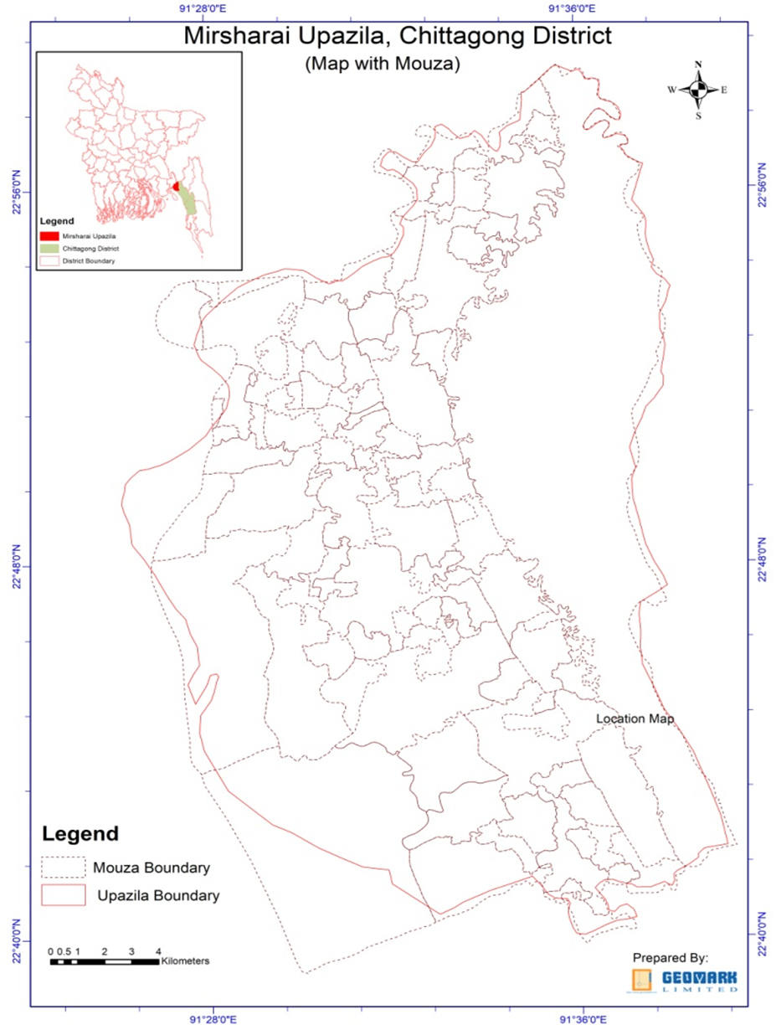
Map Source: GIS section, GEOMARK Ltd.

This area is located 192.2 km far from Dhaka and 4.5 hour bus journey. Anyone can travel by rail and it is 197 km of rail journey and it takes 4.5 hour from Dhaka to Mirsharai Upazila. 56 km from the Chittagong Divisional headquarters and takes 1.5 hour travel by bus. The Bangladesh Road Transport Corporation introduced a direct bus service from Dhaka to Mirsharai via comilla. (Source: Banglapedia, 2012)
At Mirsharai Upazila main river is Feni; Sandwip Channel is notable; canal 30, most noted of which are Feni Nadi, Isakhali, Mahamaya, Domkhali, Hinguli, Moliaish, Koila Govania and Mayani Khal. The hills range on the northern and eastern side of this upazila along the bank of the Feni River extended up to Chittagong and the Chittagong hill tracts
Historical Events: Sultan Fakhruddin Mobarak Shah conquered Chittagong in 1340 AD and established the Muslim rule in this region. During the reign of Gaur Sultans Hussain Shah and Nusrat Shah, Paragal Khan and Chhuti Khan were the rulers of this area. Subsequently Nizam Shah, brother of emperor Sher Shah, was the ruler of this area. Nizampur Pargana is named after Nizam Shah and the whole area of Mirsharai came under the control of Nizampur pargana. From the beginning of the 16th century this region was very rich in Bangla literature. Most of the time between 1580 and 1666 this region was under the control of the Arakanese. The place at which (of the present Mirsharai thana) Bujurg Umed Khan, son of Subadar Sayesta Khan, landed after crossing the Feni River was named as Bujurg Umedpur. With the conquest of Chittagong by Bujurg Umed Khan in 1666, this region came permanently under the Mughal rule. Towards the end of British rule in India, Durgapur and Karerhat areas of Mirsharai upazila were the centres of revolutionary activities of Chittagong. A fierce battle was fought between the freedom fighters (under Capt. Wali Ahmed) and the Pak army at a place adjacent to the Fenafuni Bridge on the south of Mirsharai sadar in which about 100 Pak soldiers were killed. Besides, direct encounters were held between the freedom fighters and the Pak army at many' places including Shuvapur Bridge, Hinguli Bridge, Aochi Mia Bridge and Mostan Nagar.
Main occupations: Agriculture 38.93%, non-agricultural laborer 3.61%, industry 0.57%, commerce 13.26%, transport and communication 2.93%, service 18%, construction 1.19%, religious service 0.34%, rent and remittance 8.84% and others 12.33%. Total cultivable land 22,896.40 hectares, fallow land 147713 hectares; single crop 38.91%, double crop 42.46% and treble crop land 18.63%. At present Cultivable land under irrigation is 6,917.85 hectare. Ownership of agricultural land Landowner 51.30%, landless 48.70%; agricultural landowner: urban 38.82% and rural 52.09%.

Value of land: The market value of the first grade arable land is TK. 30000 per 0.01 hectare. Main crops Paddy, potato, aborigine, bean, tomato, pumpkin and radish. Extinct or nearly extinct crops Sugarcane, jute, arahar, mustard, sesame, linseed, and ground nut. Main fruits Mango, blackberry, jackfruit, banana, papaya, litchi, pineapple, water-melon.
Communication facilities Roads: Pucca road 230 km, semi-pucca road 119 km, mud road 1435 km; railway 16 km; waterway 11 nautical miles, Rail junction 4. Extinct or nearly extinct traditional transport Palanquin, bullock cart. Noted manufactories Carpet industry, pipe mill, ice factory, rice mill, bakery, brick-field, steel furniture, fish- poultry' feed' factory, bidi factory. There are also Cottage industries, Goldsmith, blacksmith, potteries, weaving, tailoring, bamboo and wood work. Hats, bazars and fairs Hats and bazars are 52, fairs 5, most noted of which are Abu Torab Bazar, Kamar Ali Bazar, Bara Daroga Hat, Mahajan Hat, Karer Hat, Baraia Hat, Shantir Hat, Zorwarganj Baishakhi Mela, Baruni Snan Mela and Shadhinata Mela. Main exports product is Bamboo, fish, paddy, potato, banana, vegetables.
NGO Activities: Operationally important NGOs are BRAC, Proshika, ASA, Sheba, CARE, and Hunger Project. Upazila health complex 1, family planning center 16, satellite clinic 11.
Opportunity: Bangladesh can earn money in local and also in foreign exchange by opening a tourist resort at Mirsharai. The spot, if properly developed will become an excellent holiday resort and tourist centre. Rowing facility can be arranged easily; fishing and hunting facilities are already there. The success of developing Mirsharai as a tourist centre and Special Economic Zone depends much on good communication facilities and availability of modern amenities. Moreover, the proposed Special Economic Zone would generate many industry related new activities including huge vehicular traffic such as air, rail, road and water. This phenomenon would have both positive and negative impact on the socio-economic condition and existing land use pattern of the region. The proposed planning package would guide such probable changes in the socio-economic condition and land use pattern of the region, and would also address the adverse impact of such changes.

1.2 The executing agency
Urban Development Directorate (UDD) was established through a government order in 17th July 1965. This directorate is working under the Ministry of Housing and Public Works. Since its inception, UDD is contributing in developing Master Plan/Land Use Plan for small, medium and large town and cities of Bangladesh. Thus it is contributing in development of the localities and lifestyle of peoples of Bangladesh in direct and indirect ways.
Vision of UDD is to augment the quality of life of the people by improving the environment through planned development activities for adequate infrastructure, services and utility provision, to make optimum utilization of resources especially land and to ensure a geographically balance urbanization. It also aims to reduce local and regional disparity by alleviating poverty and to create good governance in the country through people participation and empowering of woman. Urban Development Directorate would welcome any co-operation, assistance and patronage from national and international quarters.

1.3 The Consultant
GEOMARK LIMITED -TILLER a Joint venture Organisation having expertise on socioeconomic survey through smart device, data processing, data analysis and report writing.

1.4 The project location
The proposed project would be prepared on a regional development perspective considering the region as a part of whole of Mirsharai Upazila and its 16 unions. In this development planning package since its location is strategically important from the regional context because this upazila is situated on the way to Dhaka Chittagong highway as the highway runs through this upazila.
Description of the Project Area: A detailed description of the Project Area is given below:
Table: Area, Population and Density of the Project Area:
Municipality | Union | Mouza | Village | Population |  | Density (per sq km) | Literacy Rate (%)
 |  |  |  | Urban | Rural | Density (per sq km) | Literacy Rate (%)
2 | 16 | 103 | 208 | 31206 | 367510 | 826 | 55.1
Source: BBS, 2011
Mirsharai sea beach, hilly area, Mohamaya Chara Lake, Khaiya Chara region has the greater potential for tourism development as there are abundant resources to attract tourists. Mirsharai is developing in an unplanned and haphazard manner very rapidly due to the ample opportunity for tourism development, which is acting as pull factor for private sector developers. Hence, this project has been under taken to protect the region from depletion of its natural resources and character and tourism development as well.
Moreover, honourable MoHPW Minister expressed his heartiest interest to develop char of this Upazila as an exclusive economic zone; as well as to establish a tourist zone and economic zone covering Mirsharai upazila.

CHAPTER TWO

2. Methodology

2.1 Reconnaissance: The reconnaissance survey is an extensive study of an entire area that might be used for a road or airfield. Its purpose is to eliminate those routes or sites which are impractical or unfeasible and to identify the more promising routes or sites. Existing maps and aerial photographs may be of great help.
2.2 Data Collection: Data collection is the process of gathering and measuring information on variables of interest, in an established systematic fashion that enables one to answer stated research questions, test hypotheses, and evaluate outcomes.
We have collected data from field survey with open-ended, close-ended questionnaire and also focus group discussion.
2.3 Data Prepare: We researchers spend a lot of time interviewing our clients to determine their needs. Then we go about carefully creating a plan to collect the data that will be most useful. Having done that, the appropriate instrument is carefully crafted that will generate data that can ultimately be transformed into knowledge. All this up-front work necessitates and lot of time and effort. And well it should! But sooner or later we will have collected data and need to start the grunt work of data preparation.
So what is involved in data preparation? There are several simple, but sometimes overlooked steps, required to properly prepare data. They are:
- Questionnaire checking: Questionnaire checking involves eliminating unacceptable questionnaires. These questionnaires may be incomplete, instructions not followed, little variance, missing pages, past cutoff date or respondent not qualified.
- Editing: Editing looks to correct illegible, incomplete, inconsistent and ambiguous answers.
- Coding: Coding typically assigns alpha or numeric codes to answers that do not already have them so that statistical techniques can be applied.
- Cleaning: Cleaning reviews data for consistencies. Inconsistencies may arise from faulty logic, out of range or extreme values.
- Statistical adjustments: Statistical adjustments applies to data that requires weighting and scale transformations.
- Analysis strategy selection: Finally, selection of a data analysis strategy is based on earlier work in designing the research project but is finalized after consideration of the characteristics of the data that has been gathered.

CHAPTER THREE

3. MOBILIZATION AND ORIENTATION

3.1 Consultant’s Organization
Geomark Ltd.is brand with specific focus to the emerging IT Enabled Services (ITES) specializing in the geospatial applications including consultancy on engineering & Architectural Design, Drawing, Supervision, planning GIS, LIS, MIS, AM/FM, processing of remote sensing data, digital mapping/surveying using GPS, geo-spatial and textual data conversion, application software and web page/solutions development and so forth. Apart from ITES, provides professional consulting services particularly for undertaking research and development studies/projects covering and not limited to land, natural resources, environment, urban/real estate development, infrastructure development, institution and organization studies, land related legislation study, human resources development studies, general education related studies, and so forth.
Tiller was founded in 2009 and grown up with focus on Urban & Regional context, developing the avenues in Urban Designing & Planning, Infrastructure Design, Disaster Management, Social Research, GIS Mapping and IT services. Tiller is led by a robust, talented & experienced group of Urban Planner, Engineer, Architect, Social Scientist, Environmental scientist and IT professionals.

The agreement between Urban Development Directorate (UDD) and consultant Geomark ltd.-Tiller has been held on 14th November, 2017 for Package-3: socioeconomic and others survey under the project Preparation of Development Plan for Mirsharai Upazila, Chittagong District: Risk Sensitive Landuse Plan. Some picture of the contract signing ceremony have been given in the next page.

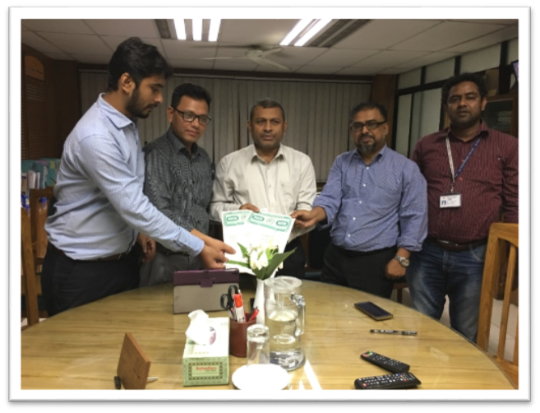

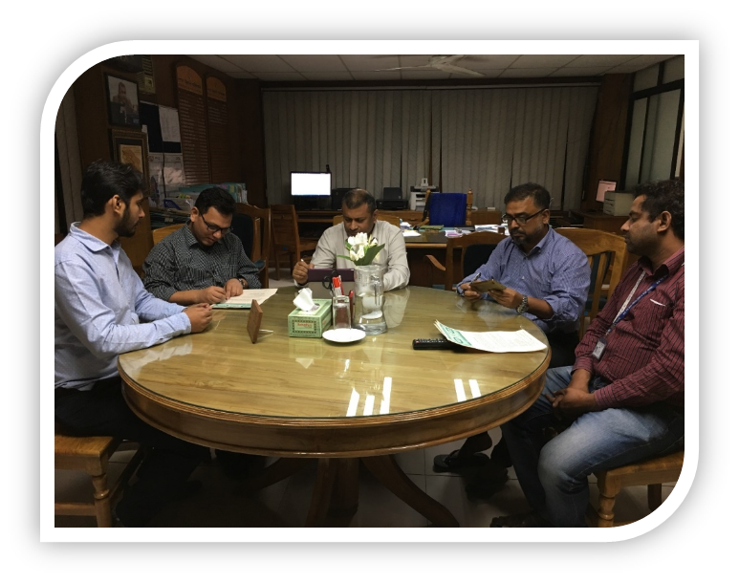
Picture: Project contract signing ceremony between Urban Development Directorate (UDD) and Geomark ltd.-Tiller join venture on 14th November, 2017.

3.2 Mobilization of THE Consultant’s Team
The contract signed on 14th November 2017, the Joint Venture (JV) team of the Geomark-Tiller has initiated their project activities with immediate action. A progress line-up from the consulting JV team is being reported here on different components of work:
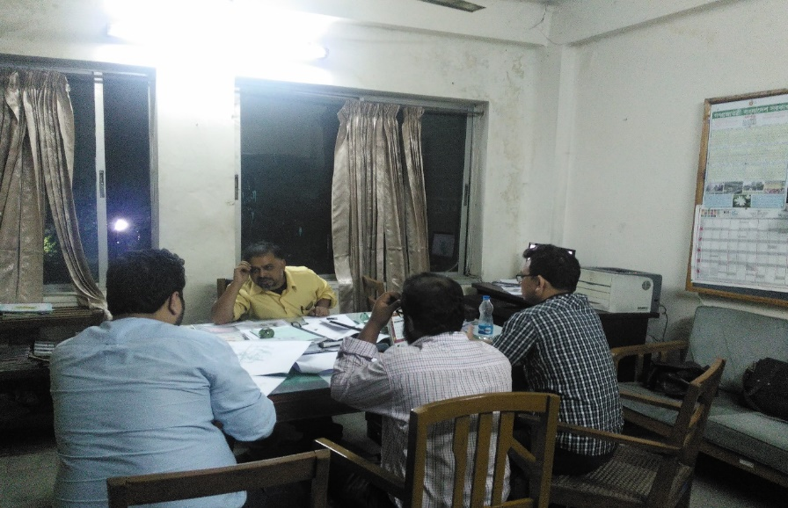
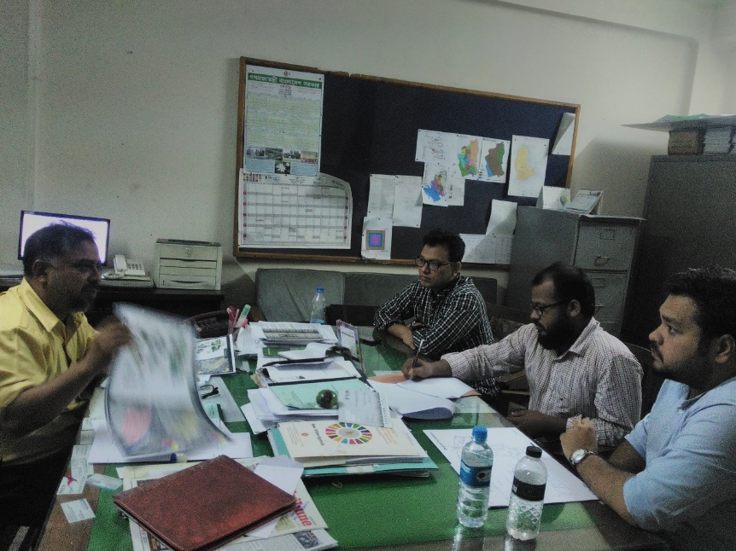
Mr. ANM Safiqul Alam Managing Director ,GEOMARK , Md Tamzidul Islam Proprietor, Tiller meet with PMO about some issue like questionnaire design, software platform design etc.
Pic: Meeting with Project Director (PD)

3.3 INITIAL MEETINGS
- Work Schedule: preparation and adjustment work is undergoing with Microsoft Project. The submission has scheduled to be made within 18th onward.
- Questionnaire preparation: A questionnaire have been prepared in according to consolidate with Project director (PD) and planners of UDD. The questionnaire have attached in the annex of this report.
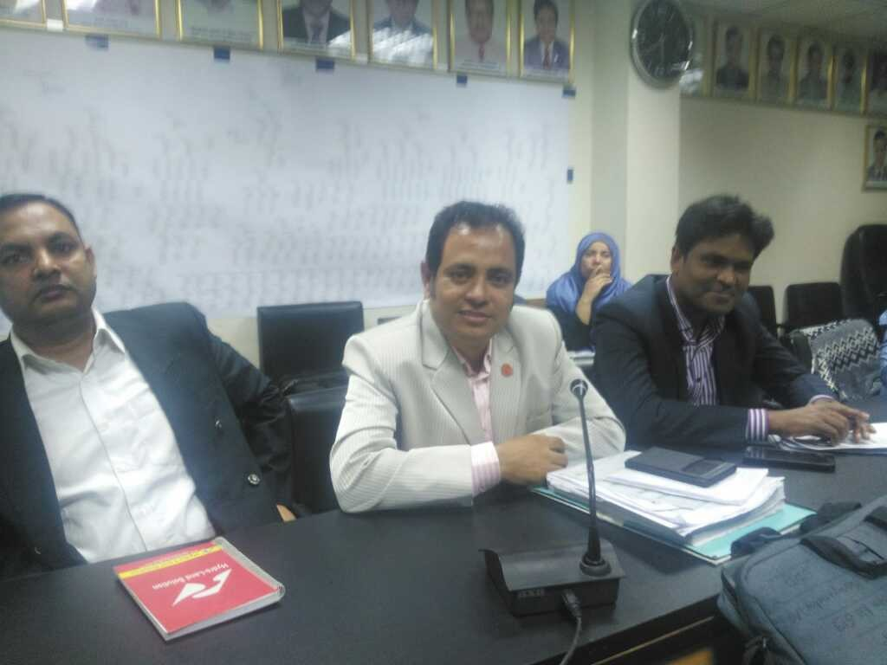
- Online data collection software preparation: For socioeconomic data collection an online free software have been used named Epicollect 5. The questionnaire already developed on Epicollect 5 software platform which have been presented in the meeting of UDD in front of all the officials of UDD including Director.
Picture: Demo picture of online data collection in the meeting.
- Inception Report Preparation: For inception report preparation it has scheduled to submit within 18th onward.
- Survey Activities: Team formation is in progress. As soon as the inception report will be approved, the team will be mobilized to the field.

CHAPTER FOUR

4. FINDINGS:
4.1 Household Characteristics:
4.1.1 Age and Sex distribution of Respondents:
In table-4.1., the age distribution of the survey area in Mirsarai is presented. It Shows that no respondents of female below 10 years. Age distribution 50-59 belongs to the highest percent of responses having 23.3%, which is quite similar (22.2%) to the preceding category 40-49 age distribution.
Table 4.1.1: Age distribution of Respondents:
Age of the Respondents
Categories | Frequency | Percent | Valid Percent | Cumulative Percent
10-19 | 39 | 3.0 | 3.0 | 3.0
20-29 | 134 | 10.3 | 10.3 | 13.3
30-39 | 203 | 15.6 | 15.6 | 28.9
40-49 | 289 | 22.2 | 22.2 | 51.2
50-59 | 303 | 23.3 | 23.3 | 74.5
60-69 | 227 | 17.5 | 17.5 | 91.9
70-79 | 80 | 6.2 | 6.2 | 98.1
80+ | 25 | 1.9 | 1.9 | 100.0
Total | 1300 | 100.0 | 100.0
Source: Field Data
Figure 4.1.1 represents the different bars having different percentages. Age category 50-59 having the highest percentage (23.3%) in figure and age category above 80 years presenting the lowest percentage (1.9%) in the bar diagram

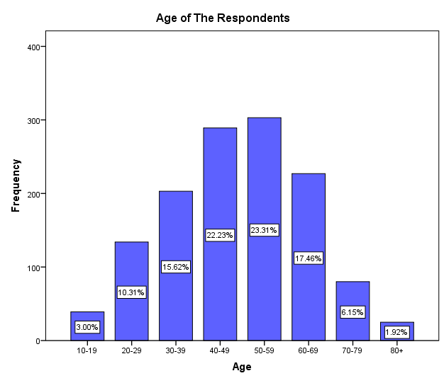Figure: Age distribution of the Respondents

4.1.2 Sex distribution of Respondents: 55.3% male respondent responses against the 44.7% female respondents in the survey
Table 4.1.2: Sex distribution of Respondents
Categories | Frequency | Percent | Valid Percent | Cumulative Percent
Male | 719 | 55.3 | 55.3 | 55.3
Female | 581 | 44.7 | 44.7 | 100.0
Total | 1300 | 100.0 | 100.0
Source: Field Data

4.1.3 Educational Status: Total eight categories in education status where illiterate considered the lowest status as usual. Total 23.3% resident in the survey area is illiterate. Maximum 33.1% of residents are observed primary education category. Higher study category as Degree/Honours/ Fazil belongs 4.7% and Masters or Higher (PhD. Doctors, lawyer, Engineer et cetera) only 1.3% in this study.
Table 4.1.3: Education Status of the respondents
Educational Level
Categories | Frequency | Percent | Valid Percent | Cumulative Percent
Illiterate | 303 | 23.3 | 23.3 | 23.3
Primary | 430 | 33.1 | 33.1 | 56.4
Junior Secondary | 133 | 10.2 | 10.2 | 66.6
SSC/Dhakil | 268 | 20.6 | 20.6 | 87.2
HSC/Alim | 79 | 6.1 | 6.1 | 93.3
Degree/Honours/ Fazil | 61 | 4.7 | 4.7 | 98.0
Masters or Higher | 17 | 1.3 | 1.3 | 99.3
Technical | 9 | .7 | .7 | 100.0
Total | 1300 | 100.0 | 100.0
Source: Field Data
4.1.4 Occupational Status: Majority of the female in survey area work at their home, so the study shows the highest percentage to occupational status Housewife, belonging 39.5%. Second highest percentage 16.55% belongs to the category Self-Independent. Self-Independent refers who are not disclose their occupational status.12.2% of the resident work in the agricultural sector in the survey area. Lowest percentage belongs to the Transport worker only 1.4% in the survey.

Table 4.1.4: Occupational Status of the Respondents
Level of Occupation
Categories | Frequency | Percent | Valid Percent | Cumulative Percent
Agriculture | 158 | 12.2 | 12.2 | 12.2
Business(Small/Medium) | 92 | 7.1 | 7.1 | 19.2
Construction Work | 36 | 2.8 | 2.8 | 22.0
Day Labour | 96 | 7.4 | 7.4 | 29.4
Government Job | 36 | 2.8 | 2.8 | 32.2
Housewife | 513 | 39.5 | 39.5 | 71.6
Skilled labour | 24 | 1.8 | 1.8 | 73.5
Private Job | 43 | 3.3 | 3.3 | 76.8
Self-independent | 215 | 16.5 | 16.5 | 93.3
Shopkeeper | 18 | 1.4 | 1.4 | 94.7
Student | 51 | 3.9 | 3.9 | 98.6
Transport Work | 18 | 1.4 | 1.4 | 100.0
Total | 1300 | 100.0 | 100.0
Source: Field Data
4.1.5: Marital Status: Marital Status divided into four categories-Married, Unmarried, Widow/Widower and Separated, 86% respondent in the survey is married, 8.4% are unmarried, Widow/Widower and Separated categories are approximately same 2.8% and 2.3% respectively.
Table 4.1.5: Marital Status of the Respondents
Categories | Frequency | Percent | Valid Percent | Cumulative Percent
Married | 1124 | 86.5 | 86.5 | 86.5
Unmarried | 109 | 8.4 | 8.4 | 94.8
Widow/Widower | 37 | 2.8 | 2.8 | 97.7
Separated | 30 | 2.3 | 2.3 | 100.0
Total | 1300 | 100.0 | 100.0
Source: Field Data
4.1.6: Family Type: Majority of the family in the survey are single type, 72.7% of the total families are single family in this area, and rest of the percentage (27.3%) belongs to the Join Family.
Table 4.1.6: Distribution of Family Type
Family Type
Categories | Frequency | Percent | Valid Percent | Cumulative Percent
Single | 982 | 72.7 | 72.7 | 72.7
Join | 368 | 27.3 | 27.3 | 100.0
Total | 1350 | 100.0 | 100.0
Source: Field Data
4.1.7: Family Members: Majority of the Family size (53.2%) lies in the category 05-09. In the Table 4.1.7 shows that only .2% having the 20 or family members. 38.4% family size is less than five members.
Table 4.1.7: Distribution of Number of Family Members
Number of Family Members
Categories | Frequency | Percent | Valid Percent | Cumulative Percent
<5 | 519 | 38.4 | 38.4 | 38.4
05-09 | 718 | 53.2 | 53.2 | 91.6
10-14 | 93 | 6.9 | 6.9 | 98.5
15-19 | 17 | 1.3 | 1.3 | 99.8
20+ | 3 | .2 | .2 | 100.0
Total | 1350 | 100.0 | 100.0
Source: Field Data
4.1.8: Religion: Muslim Hindu and Buddhist are the main three religion in the survey area. Majority of 85% belongs the Muslim, 13.8% to the Hindu and rest of the percentage (1.2%) belongs to the Buddhist.

Table 4.1.8: Distribution of Religion
Religion
Categories | Frequency | Percent | Valid Percent | Cumulative Percent
Muslim | 1148 | 85.0 | 85.0 | 85.0
Hindu | 186 | 13.8 | 13.8 | 98.8
Buddhist | 16 | 1.2 | 1.2 | 100.0
Total | 1350 | 100.0 | 100.0
Source: Field Data
4.2: Characteristics of Autism and Disability
4.2.1 Autism: Asperger Syndrome, Autistic Disorder/Classic Autism and Pervasive Developmental Disorder these three kinds of autistic case found in the survey area. Total 37 cases were found in the survey area. Among the total of the cases 33 cases were Autistic Disorder/Classic Autism, which represent the 89.2% of the total autism in the Table 4.2.1.
Table 4.2.1: Distribution of Autism
Types of Autism
Categories | Frequency | Percent | Valid Percent | Cumulative Percent
Asperger Syndrome | 1 | .1 | 2.7 | 2.7
Autistic Disorder/Classic Autism | 33 | 2.4 | 89.2 | 91.9
Pervasive Developmental Disorder | 3 | .2 | 8.1 | 100.0
Total | 37 | 2.7 | 100.0
Source: Field Data
4.2.2: Disability: Majority of the disability found as a physical disabilities, which belongs to the 54.5% of the total categories.

Table 4.2.2: Distribution of Disable Family Members
Types of Disability
Categories |  | Frequency |  | Percent |  | Valid Percent |  | Cumulative Percent
Hearing Disabilities |  | 1 |  | .1 |  | 9.1 |  | 9.1
Learning Disabilities |  | 1 |  | .1 |  | 9.1 |  | 18.2
Mental Health Disabilities |  | 2 |  | .2 |  | 18.2 |  | 36.4
Physical Disabilities |  | 6 |  | .5 |  | 54.5 |  | 90.9
Visual Disabilities |  | 1 |  | .1 |  | 9.1 |  | 100.0
Total | 11 |  | .8 |  | 100.0
Source: Field Data
  - Household Income, Expenditure and Savings
4.3.1: Income of the Household: In the Table 4.3.1, showing the maximum income category is (TK10,000-TK14,000) belongs to the 22.1%.
Table 4.3.1: Percentage distribution of Household income
Household Monthly Income (TK)
Categories | Frequency | Percent | Valid Percent | Cumulative Percent
<5,000 | 49 | 3.6 | 3.6 | 3.6
05,000- 09,000 | 261 | 19.3 | 19.3 | 23.0
10,000-14,000 | 298 | 22.1 | 22.1 | 45.0
15,000-19,000 | 228 | 16.9 | 16.9 | 61.9
20,000-24,000 | 188 | 13.9 | 13.9 | 75.9
25,000-29,000 | 112 | 8.3 | 8.3 | 84.1
30,000-34,000 | 70 | 5.2 | 5.2 | 89.3
35,000-39,000 | 50 | 3.7 | 3.7 | 93.0
40,000-44,000 | 28 | 2.1 | 2.1 | 95.1
45,000-49,000 | 28 | 2.1 | 2.1 | 97.2
50,000 + | 38 | 2.8 | 2.8 | 100.0
Total | 1350 | 100.0 | 100.0
Source: Field Data

TK50,000 and more income belongs to the only 2.8% of the resident in the survey area. Monthly income below TK5,000 belongs to the 3.6% of the residents.

Figure4.3.1: Bar diagram of Household monthly Income
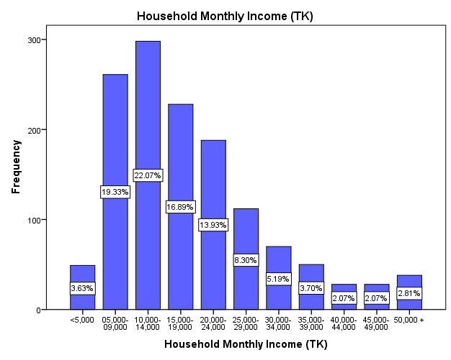
4.3.2: Expenditure of Household: Majority of the expenses belongs to expenditure on food, In the Figure 4.3.2, showing the 52.45% belongs to the expenditure on food, expenditure on house rent presents 1.27% because of the maximum of the residents in the survey area reside their own house. 9.66% of their expenses belongs to the educational purpose, 11.88% to the health and so on.
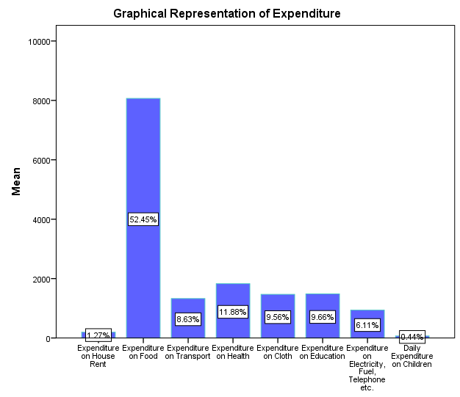Figure4.3.2: Bar Diagram of Household Expenditures
4.3.3: Savings of Household: In the Table4.3.3 showing the 75.1% respondents in the survey area are with zero savings. Less than TK1,000 saves by the 9% of the respondents. Only 2.7% respondents are manage to save TK 7,000 and more.
Table 4.3.3: Distribution of Household Savings
Monthly Savings
Categories | Frequency | Percent | Valid Percent | Cumulative Percent
0 | 1014 | 75.1 | 75.1 | 75.1
<1000 | 122 | 9.0 | 9.0 | 84.1
1,000-1,900 | 69 | 5.1 | 5.1 | 89.3
2,000-2,900 | 39 | 2.9 | 2.9 | 92.1
3,000-3,900 | 10 | .7 | .7 | 92.9
5,000-5,900 | 53 | 3.9 | 3.9 | 96.8
6,000-6,900 | 6 | .4 | .4 | 97.3
7,000+ | 37 | 2.7 | 2.7 | 100.0
Total | 1350 | 100.0 | 100.0
4.4: Family Members Staying outside
4.4.1: Distribution of family members staying outside: Staying outside of the home could be in two categories-Permanent & Temporary. Among the resident of total number of people staying outside the Mirsharai, 44.2 % belongs to the people who are staying outside country temporarily. Only 4.8% are staying outside of the country permanently.
In the Table 4.4.1, showing the 40.2% belongs to the category people who are staying other parts of the country temporarily.
Table 4.4.1: Distribution of family members staying outside
Staying Outside of Mirsharai Upazila
Categories | Frequency | Percent | Valid Percent | Cumulative Percent
Country(Permanent) | 43 | 10.8 | 10.8 | 10.8
Country(Temporary) | 160 | 40.2 | 40.2 | 51.0
Outside Country (Permanent) | 19 | 4.8 | 4.8 | 55.8
Outside Country (Temporary) | 176 | 44.2 | 44.2 | 100.0
Total | 398 | 100.0 | 100.0
Source: Field Data
4.4.2: Reasons for Living outside Mirsharai Upazila:It could be different reasons for staying outside, In the Table 4.4.2, Job/Workplace category one of the main reason to staying outside of the home, which belongs to the 68.8%.Business responsible for only 5.8% for staying outside. For higher education one of the reason to staying people staying outside the home, because higher educational institutions are not available here, so that 14.6% are staying outside of the Mirsharai.

Table 4.4.2: Distribution of reasons for living outside
Reasons for Living Outside Mirsharai Upazila
Categories |  | Frequency |  | Percent |  | Valid Percent |  | Cumulative Percent
Business |  | 23 |  | 5.8 |  | 5.8 |  | 5.8
Environmental Reasons |  | 43 |  | 10.8 |  | 10.8 |  | 16.6
Job/Workplace |  | 274 |  | 68.8 |  | 68.8 |  | 85.4
Higher Education |  | 58 |  | 14.6 |  | 14.6 |  | 100.0
Total | 398 |  | 100.0 |  | 100.0
Source: Field Data
4.5: Structure
4.5.1: Structure of House: Half of structures in the survey area are katcha, 52.8% structure is katcha, and 23.5% belongs to the pucca structure,
Table 4.5.1: Distribution of House Structure
Structure of House
Categories | Frequency | Percent | Valid Percent | Cumulative Percent
Jhupri | 112 | 8.8 | 8.8 | 8.8
Katcha | 671 | 52.8 | 52.8 | 61.6
Semi Pucca | 189 | 14.9 | 14.9 | 76.5
Pucca | 299 | 23.5 | 23.5 | 100.0
Total | 1271 | 100.0 | 100.0
Source: Field Data
4.5.2 Number of Floor of Pucca Structure: Majority of the pucca structures are having one storied building, 85.5% structures belongs to the one-storied. 9.9% structures are two storied, only 1.5% having the four storied.

Table 4.5.2: Distribution of Number of Floor (Pucca Structure)
Number of Floor(Pucca Structure)
Number of Floors | Frequency | Percent | Valid Percent | Cumulative Percent
1 | 224 | 85.5 | 85.5 | 85.5
2 | 26 | 9.9 | 9.9 | 95.4
3 | 7 | 2.7 | 2.7 | 98.1
4 | 4 | 1.5 | 1.5 | 99.6
5 | 1 | .4 | .4 | 100.0
Total | 262 | 100.0 | 100.0
Source: Field Data
4.5.3 Construction Year of House: In the Table 4.5.3, showing the 63.5% of the home structure constructed in the 1980 to 2010.Old structure which are constructed in the year 1890 to 1920, belongs to .6%.
Table 4.5.3: Distribution of Construction year of House
Construction Year of House
Year |  | Frequency |  | Percent |  | Valid Percent |  | Cumulative Percent
1890-1920 |  | 7 |  | .6 |  | .6 |  | .6
1920-1950 |  | 18 |  | 1.6 |  | 1.6 |  | 2.2
1950-1980 |  | 76 |  | 6.7 |  | 6.7 |  | 8.9
1980-2010 |  | 723 |  | 63.5 |  | 63.5 |  | 72.4
2010-2018(current year) |  | 314 |  | 27.6 |  | 27.6 |  | 100.0
Total | 1138 |  | 100.0 |  | 100.0
Source: Field Data

4.5.4 Foundation Type of House: Majority of the foundations are RCC foundation in the survey area. RCC foundation belongs to the 49%, Brick foundation belongs to the 34.5% and rest of the foundations are count as an others belongs to the 16.6%
Table 4.5.4: Distribution of Foundation Type
Foundation Type of House
Categories |  | Frequency |  | Percent |  | Valid Percent |  | Cumulative Percent
Brick |  | 233 |  | 34.5 |  | 34.5 |  | 34.5
RCC |  | 331 |  | 49.0 |  | 49.0 |  | 83.4
Others |  | 112 |  | 16.6 |  | 16.6 |  | 100.0
Total | 676 |  | 100.0 |  | 100.0
Source: Field Data
4.5.5 House Soil Type: In the Table 4.5.5, showing the 79% of the house soil type is Muddy land, minimum 1.9% belongs to the Red Soil in the survey area. Sand soil belongs to the 17.2% as house soil type.
Table 4.5.5: Distribution of house soil type
House Soil Type
Categories | Frequency | Percent | Valid Percent | Cumulative Percent
Muddy Land | 1066 | 79.0 | 79.0 | 79.0
Red Soil | 25 | 1.9 | 1.9 | 80.8
Rock Soil | 27 | 2.0 | 2.0 | 82.8
Sand Soil | 232 | 17.2 | 17.2 | 100.0
Total | 1350 | 100.0 | 100.0
Source: Field Data

4.5.6 Land Price: In the figure 4.5.6, the upward sloping line diagram showing the increases of land prices during the year 2002 to 2017.
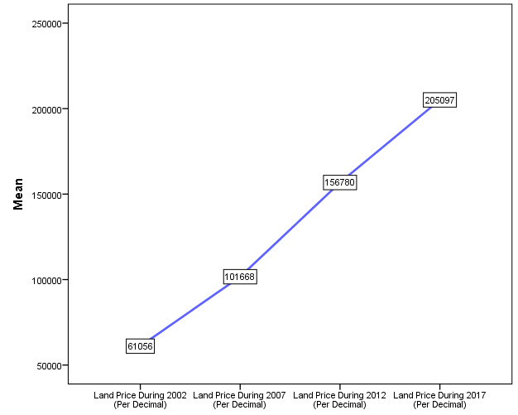
Figure: Line Diagram Showing the land prices in different years (2002-2017)

4.6 Road
4.6.1 Road width in-front of House (meter): Road width in front of house represent the 29.4% roads are two meter width, 25.3% are three meter width, only .1% are 7 meter width in the count
Table 4.6.1 Road width in-front of House (meter)
Road width in-front of House (m)?
Categories(m) |  | Frequency |  | Percent |  | Valid Percent |  | Cumulative Percent
1 |  | 268 |  | 19.9 |  | 19.9 |  | 19.9
2 |  | 397 |  | 29.4 |  | 29.4 |  | 49.3
3 |  | 341 |  | 25.3 |  | 25.3 |  | 74.5
4 |  | 54 |  | 4.0 |  | 4.0 |  | 78.5
5 |  | 139 |  | 10.3 |  | 10.3 |  | 88.8
6 |  | 33 |  | 2.4 |  | 2.4 |  | 91.3
7 |  | 1 |  | .1 |  | .1 |  | 91.3
8 |  | 117 |  | 8.7 |  | 8.7 |  | 100.0
Total | 1350 |  | 100.0 |  | 100.0
Source: Field Data
4.6.2 Road Type: Road types are divided in five categories, 31.9% of them are Asphalt, similarly 31.6% are BS, Katcha roads belongs to the 29.8%. HBB and RCC are belongs to the less than 10%, as 2.1% and 4.6% respectively.
Table 4.6.2: Distribution of Road Type
Road Type
Categories |  | Frequency |  | Percent |  | Valid Percent |  | Cumulative Percent
Asphalt |  | 431 |  | 31.9 |  | 31.9 |  | 31.9
BS |  | 426 |  | 31.6 |  | 31.6 |  | 63.5
HBB |  | 29 |  | 2.1 |  | 2.1 |  | 65.6
Katcha |  | 402 |  | 29.8 |  | 29.8 |  | 95.4
RCC |  | 62 |  | 4.6 |  | 4.6 |  | 100.0
Total | 1350 |  | 100.0 |  | 100.0

4.6.3 Main Road distance from House (meter):47.9% distances are less than 1000 meters, highest distance category 8000-9000 belongs to the 10.1%, other distance categories not more than the 10% in count.

Table 4.6.3: Distribution of distances
Main Road distance from House(meter)
Categories |  | Frequency |  | Percent |  | Valid Percent |  | Cumulative Percent
<1000 |  | 646 |  | 47.9 |  | 47.9 |  | 47.9
1000-2000 |  | 111 |  | 8.2 |  | 8.2 |  | 56.1
2000-3000 |  | 73 |  | 5.4 |  | 5.4 |  | 61.5
3000-4000 |  | 80 |  | 5.9 |  | 5.9 |  | 67.4
4000-5000 |  | 67 |  | 5.0 |  | 5.0 |  | 72.4
5000-6000 |  | 104 |  | 7.7 |  | 7.7 |  | 80.1
6000-7000 |  | 40 |  | 3.0 |  | 3.0 |  | 83.0
7000-8000 |  | 45 |  | 3.3 |  | 3.3 |  | 86.4
8000-9000 |  | 48 |  | 3.6 |  | 3.6 |  | 89.9
9000-10000 |  | 136 |  | 10.1 |  | 10.1 |  | 100.0
Total | 1350 |  | 100.0 |  | 100.0
Source: Field Data
4.6.4 Condition of Main Road: in the Table 4.6.4, showing the 49% of the respondents said that the condition of the main road is good, 51% rest of the respondents said that not good.
Table 4.6.4: Distribution of Main Road Condition
Categories | Frequency | Percent | Valid Percent | Cumulative Percent
Good | 662 | 49.0 | 49.0 | 49.0
Not Good | 688 | 51.0 | 51.0 | 100.0
Total | 1350 | 100.0 | 100.0
Source: Field Data
4.6.5 Problem of Main Road: Three main problems identified in the survey, 61.2% of the respondents said that the main problem of the main road is narrow road, 12.7% belongs to the occupied by wastages & Hawker. Traffic jam is the main problem said only 3.3%.

Table 4.6.5: Distribution of Main Road Problem
Problem of Main Road
Categories | Frequency | Percent | Valid Percent | Cumulative Percent
Narrow | 826 | 61.2 | 61.2 | 61.2
Occupied by Wastages & Hawker | 171 | 12.7 | 12.7 | 73.9
Traffic Jam | 44 | 3.3 | 3.3 | 77.1
Others | 309 | 22.9 | 22.9 | 100.0
Total | 1350 | 100.0 | 100.0
Source: Field Data
4.6.6 Light post: In the table 4.6.6, showing the 94.2% of the road without having light post, and rest of 5.8% are having light post.
Table 4.6.6: Distribution of light Post
Light post
Categories | Frequency | Percent | Valid Percent | Cumulative Percent
Yes | 78 | 5.8 | 5.8 | 5.8
No | 1272 | 94.2 | 94.2 | 100.0
Total | 1350 | 100.0 | 100.0

4.6.7: Drain: In the table 4.6.7, 84.7% areas are without drainage system, 15.3% having the drain, among the 15.3%, 10.4% drains are katcha and 4.9% are pucca drain.
Table 4.6.7: Distribution of Drain
Drain
Categories |  | Frequency |  | Percent |  | Valid Percent |  | Cumulative Percent
Katcha |  | 140 |  | 10.4 |  | 10.4 |  | 10.4
Pucca |  | 66 |  | 4.9 |  | 4.9 |  | 15.3
No Drain |  | 1144 |  | 84.7 |  | 84.7 |  | 100.0
Total | 1350 |  | 100.0 |  | 100.0
Source: Field Data
4.7 Water Sources
4.7.1 Sources of Water: Majority percentage of water sources (85.9%) belongs to the Tube well. 2.8% water sources belongs to the pipeline, and the rest of the sources not more than 5%, pond and river/canal source belongs to the 3.2% and 2.9% respectively.
Table 4.7.1: Distribution of Water sources
Source of Water
Categories | Frequency | Percent | Valid Percent | Cumulative Percent
Comon Tube well | 70 | 5.2 | 5.2 | 5.2
Pipeline | 38 | 2.8 | 2.8 | 8.0
Tubewell | 1160 | 85.9 | 85.9 | 93.9
Pond | 43 | 3.2 | 3.2 | 97.1
River/Canal | 39 | 2.9 | 2.9 | 100.0
Total | 1350 | 100.0 | 100.0
Source: Field Data

4.7.2 Quality of water: Among all the water sources 88.8% water is drinkable, 9% sources are Arsenic Contaminated, and the rest of the sources (2.1%) are not drinkable.
Table 4.7.2: Distribution of water Quality
Quality of Water
Categories |  | Frequency |  | Percent |  |  | Valid Percent |  | Cumulative Percent
Arsenic Contaminated |  | 122 |  | 9.0 |  |  | 9.0 |  | 9.0
Drinkable |  | 1199 |  | 88.8 |  |  | 88.8 |  | 97.9
Not Drinkable |  | 29 |  | 2.1 |  | 2.1 |  |  | 100.0
Total | 1350 |  | 100.0 |  | 100.0
Source: Field Data

4.8 Source of Fuel
4.8.1 Sources of Fuel: In the Table 4.8.1, showing the majority percent of fuel source come from the wood, which belongs to the 82.5%, second maximum fuel source is cylinder gas (13.15), and the rest of the sources are pipeline gas and others belongs to the 3.1% and 1.3% respectively.
Table 4.8.1: Distribution of Fuel Sources
Source of Fuel
Categories |  | Frequency |  | Percent |  | Valid Percent |  | Cumulative Percent
Cylinder Gas |  | 177 |  | 13.1 |  | 13.1 |  | 13.1
Wood |  | 1113 |  | 82.5 |  | 82.5 |  | 95.6
Pipeline Gas |  | 42 |  | 3.1 |  | 3.1 |  | 98.7
Others |  | 17 |  | 1.3 |  | 1.3 |  | 100.0
Total | 1349 |  | 100.0 |  | 100.0
Source: Field Data
4.8.2 Sources of Light: Electricity (91.2%) is the main source of light in this area. Solar panel belongs to the 5.5% of the light source in this area.
Table 4.8.2: Distribution of Light Source
Source of Light
Categories |  | Frequency |  |  | Percent |  | Valid Percent |  | Cumulative Percent
Electricity |  | 1230 |  |  | 91.2 |  | 91.2 |  | 91.2
Kupi/Bati/Harican |  | 45 |  |  | 3.3 |  | 3.3 |  | 94.5
Solar Electricity |  |  | 74 |  | 5.5 |  | 5.5 |  | 100.0
Total | 1349 |  |  | 100.0 |  | 100.0
Source: Field Data

4.9 Sanitation
4.9.1 Types of Latrine: Latrine types divided into three categories, the majority of the percentage (58.0%) belongs to the katcha latrine. It is observed that in the table 4.9.1, Pucca latrine is 24.7% and the rest 17.3% belongs to the Semi pucca latrine.
Table 4.9.1: Distribution of types of latrine
Type of Sanitation
Categories |  | Frequency |  | Percent |  | Valid Percent |  | Cumulative Percent
Katcha |  | 783 |  | 58.0 |  | 58.0 |  | 58.0
Pucca |  | 334 |  | 24.7 |  | 24.7 |  | 82.7
Semi Pucca |  | 233 |  | 17.3 |  | 17.3 |  | 100.0
Total | 1350 |  | 100.0 |  | 100.0
Source: Field Data
4.9.2 Is latrine hygienic? During the identification of hygienic latrine, 83.0% respondent’s response to the hygienic latrine, and the rest of the respondents (17.0%) said that latrine is not hygienic.
Table: Distribution of hygienic latrine
Is sanitation is hygenic?
Categories |  | Frequency |  | Percent |  | Valid Percent |  | Cumulative Percent
Yes |  | 1121 |  | 83.0 |  | 83.0 |  | 83.0
No |  | 229 |  | 17.0 |  | 17.0 |  | 100.0
Total | 1350 |  | 100.0 |  | 100.0
Source: Field Data
4.10 Diseases
4.10.1 Attacked by diseases in the last year: Regarding the categories of different kinds of diseases, it is found that 64.8% of the respondents having cough in the last year. 8.4% response to the dysentery, 14.6% respondents did not identify any specific disease, but respondent had been attacked by the disease

Table 4.10.1: Distribution of Diseases
Disease Name Attacked By Last Year
Categories |  | Frequency |  | Percent |  | Valid Percent |  | Cumulative Percent
Cough |  | 377 |  | 30.5 |  | 64.8 |  | 64.8
Diabatic |  | 18 |  | 1.5 |  | 3.1 |  | 67.9
Hart attack |  | 23 |  | 1.9 |  | 4.0 |  | 71.8
Kidney Diseases |  | 1 |  | .1 |  | .2 |  | 72.0
Diarrhoea |  | 17 |  | 1.4 |  | 2.9 |  | 74.9
Dysentery |  | 49 |  | 4.0 |  | 8.4 |  | 83.3
Skin Diseases |  | 6 |  | .5 |  | 1.0 |  | 84.4
Jaundice |  | 6 |  | .5 |  | 1.0 |  | 85.4
Others |  | 85 |  | 6.9 |  | 14.6 |  | 100.0
Total | 582 |  | 47.0 |  | 100.0
Source: Field Data
4.10.2 Hospital/Medical facilities distance from house (meter): Distance between nearest hospital and respondent’s house has been divided into five categories, categories of 1000-5000 meter belongs to the 42.8% respondents. Below 1000 meter observed that the 22.1%, and minimum response (5.2%) belongs to the category 15000-20000 meter.
Table 4.10.2: Distribution of Hospital/Medical facilities Distance from House
Hospital/Medical facilities distance from house(m)
Categories | Frequency | Percent | Valid Percent | Cumulative Percent
<1000 | 242 | 22.1 | 22.1 | 22.1
1000-5000 | 470 | 42.8 | 42.8 | 64.9
5000-10000 | 235 | 21.4 | 21.4 | 86.3
10000-15000 | 93 | 8.5 | 8.5 | 94.8
15000-20000 | 57 | 5.2 | 5.2 | 100.0
Total | 1097 | 100.0 | 100.0
Source: Field Data

4.11 Educational Institution
4.11.1 Nearest Primary School Distance (m): Nearest primary school distances from the respondent’s house is represented in the Table 4.11.1, 75.3% response belongs to the 1000-2000 (m) category. 17% schools, distance below 1000 meter, and the rest of (7.5%) belongs to the 2000-3000 meters category.
Table4.11.1: Distribution of distances of nearest Primary School
Nearer Primary School Distance (M)
Categories | Frequency | Percent | Valid Percent | Cumulative Percent
<1000 | 78 | 17.2 | 17.2 | 17.2
1000-2000 | 342 | 75.3 | 75.3 | 92.5
2000-3000 | 34 | 7.5 | 7.5 | 100.0
Total | 454 | 100.0 | 100.0
Source: Field Data
4.11.2 Nearest High School Distance (m): The Majority of the high school(55.6%) situated in the 1000-2000 meters range. Only 5.6% high school situated 1000 meter in the survey area. 4000 meters & above distance from the house belongs to the 2.8%.
Table 4.11.2: Distribution of distance of nearest high school
Nearer Secondary School Distance (m)
Categories | Frequency | Percent | Valid Percent | Cumulative Percent
<1000 | 28 | 5.6 | 5.6 | 5.6
1000-2000 | 277 | 55.6 | 55.6 | 61.2
2000-3000 | 141 | 28.3 | 28.3 | 89.6
3000-4000 | 38 | 7.6 | 7.6 | 97.2
4000 & above | 14 | 2.8 | 2.8 | 100.0
Total | 498 | 100.0 | 100.0
Source: Field Data
4.12 Recreation
4.12.1 Location for Recreation: The study shows the most favorite destination for recreation in the survey is Local Town/Playing Field/Backyard, which is represented 56.5% respondents.
Khaiyachora waterfall and Mohamaya Lake are the very popular travel destination in Bangladesh. But in the survey area 18.1% resident chooses Mohamaya Lake as their recreation destination and Khaiyachora/Napittachora chosen 8.8% residents as their recreation site.
Table 4.12.1: Distribution of Recreation Location
Location for Recreation
Categories | Frequency | Percent | Valid Percent | Cumulative Percent
Chittagong City/Cox's Bazar/Feni/Others | 7 | 2.0 | 2.0 | 2.0
Khaiyachara/Napittachara Waterfall | 31 | 8.8 | 8.8 | 10.7
Local Town/Playing Field/Backyard | 200 | 56.5 | 56.5 | 67.2
Mohamaya Lake | 64 | 18.1 | 18.1 | 85.3
Shoping Mall | 43 | 12.1 | 12.1 | 97.5
Sitakundo Hill Area | 9 | 2.5 | 2.5 | 100.0
Total | 354 | 100.0 | 100.0
Source: Field Data

4.13 Natural Disaster
4.13.1 Cyclone/Tornedo in survey area (Year): Cyclone/Tornado is one of the most destructive natural disaster in our country, in the table 4.13.1, showing the year interval 1991-2000 was the most vulnerable year presenting 38.3% cyclone/Tornedo hits that decade. In the year category 1971-1980 belongs to the only .5% Cyclone/tornedo recorded.

Table 4.13.1: Distribution of cyclone/Tornedo
Cyclone/Tornedo in your area(Year)
Categories | Frequency | Percent | Valid Percent | Cumulative Percent
1971-1980 | 3 | .5 | .5 | .5
1981-1990 | 21 | 3.5 | 3.5 | 4.0
1991-2000 | 230 | 38.3 | 38.3 | 42.3
2001-2010 | 169 | 28.2 | 28.2 | 70.5
2011-2017 | 177 | 29.5 | 29.5 | 100.0
Total | 600 | 100.0 | 100.0
Source: Field Data
4.13.2 Water Logging in survey area: Because of low area 64.9% area faces water logging in the survey area. No drainage system in the area causes for 13.4% water logging.
Table 4.13.2: Distribution of water logging
Cause of water logging
Categories | Frequency | Percent | Valid Percent | Cumulative Percent
Lock of Drainage System | 83 | 9.5 | 9.5 | 9.5
Low Area | 566 | 64.9 | 64.9 | 74.4
Low Area, No drainage system | 106 | 12.2 | 12.2 | 86.6
No drainage system | 117 | 13.4 | 13.4 | 100.0
Total | 872 | 100.0 | 100.0
Source: Field Data

4.13.3 Duration of water logging: The majority of the water logging time in the survey area is more than 5 hours, which belongs to 63.4% of the total. Minimum 8.3% duration belongs to 3-5 hours category. 13.4% water logging causes less than 1 hour duration.
Table 4.13.3: Distribution of water logging Time
Duration of Water logging
Categories |  | Frequency |  | Percent |  | Valid Percent |  | Cumulative Percent
Less than 1 hours |  | 119 |  | 13.4 |  | 13.4 |  | 13.4
1-3 Hours |  | 133 |  | 14.9 |  | 14.9 |  | 28.3
3-5 hours |  | 74 |  | 8.3 |  | 8.3 |  | 36.6
More than 5 hours |  | 565 |  | 63.4 |  | 63.4 |  | 100.0
Total | 891 |  | 100.0 |  | 100.0
Source: Field Data
4.14.1 First problem in this area: Among the all problems recorded in the survey area, load shedding having the maximum percentage (42.9%). Road problem also have the significant percentage (22.5%) in the survey area. Sewerage problem and water logging problems are related, due to interrupted sewerage facilities then definitely there would a arise water logging problem.

Table 4.14.1: Distribution of First Problem in Area
First Problem In This Area
Categories | Frequency | Percent | Valid Percent | Cumulative Percent
Disorganization of Law | 13 | 1.1 | 1.1 | 1.1
Flash Flood | 11 | .9 | .9 | 2.0
Lack of Drinking water | 8 | .7 | .7 | 2.7
Lack of Eligible Educational Institution | 86 | 7.2 | 7.2 | 9.9
Lack of Waste Disposal Point | 20 | 1.7 | 1.7 | 11.6
Load Shedding | 511 | 42.9 | 42.9 | 54.5
Long Distance of Bazar | 21 | 1.8 | 1.8 | 56.3
Road | 268 | 22.5 | 22.5 | 78.8
Sewerage Problem | 25 | 2.1 | 2.1 | 80.9
Traffic Jam | 6 | .5 | .5 | 81.4
Transportation | 57 | 4.8 | 4.8 | 86.1
Water Logging | 119 | 10.0 | 10.0 | 96.1
Others | 46 | 3.9 | 3.9 | 100.0
Total | 1191 | 100.0 | 100.0
Source: Field Data
In the figure 4.14.1, showing the water logging problem is one of the main problem in the survey area, which belongs to 10%, and 2.1% belongs to the sewerage problem.

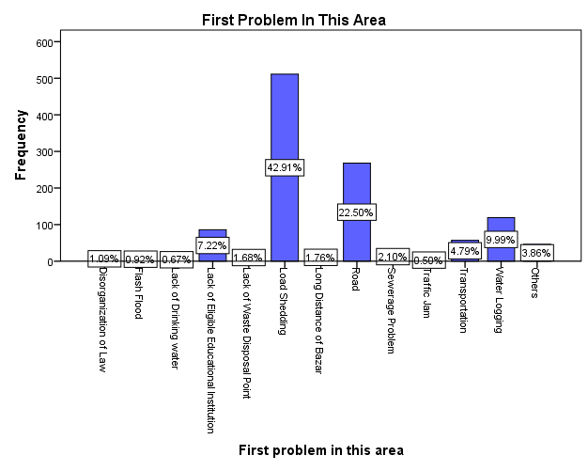Figure 4.14.1: Bar Diagram of First problem of the Area
4.14.2 Land mark/icon/historical place is known to all in mirsharai upazila: In the Figure 4.14.2, respondents are consider their choice how to describe their area in one word, in this way 32.32% residents chooses the Mohamaya Lake which is better describe the Mirsharai upazila they think. Khoichora waterfall is one of the important natural beauty in Mirshari which belongs to 15.05%.

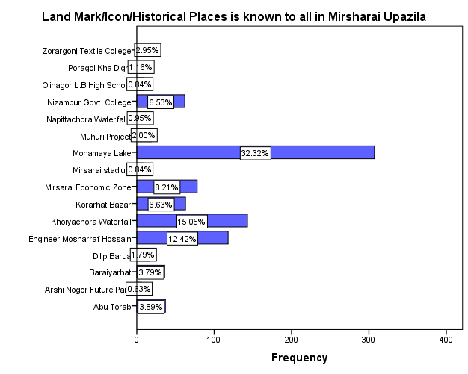Figure 4.14.2: Bar diagram showing the distribution Land mark/icon/historical places:

Political leaders also represented the mirsharai, Engineer Mosharraf Hossain and Dilip Barua are representing Mirsharai, and Engineer Mosharraf Hossainis is a Minister of Housing and Public Works in current government of Bangladesh chosen by 12.42% of the respondents as well consider that he is representing Mirshari very well.

4.14.3 Socioeconomic development for development of Mahamaya and Khoiachara Tourism Spot: Tourism is an important factor for development of an area. Natural beauties like Mahamaya and Khoiachora are the two important tourist spot in Mirsharai,
Table 4.14.3: Distribution of Socioeconomic development of Tourism Spot
Categories | Frequency | Percent | Valid Percent | Cumulative Percent
Yes | 1029 | 93.3 | 93.3 | 93.3
No | 74 | 6.7 | 6.7 | 100.0
Total | 1103 | 100.0 | 100.0
Source: Field Data
93.3% of the respondent to think that it is important to develop the two tourist spot considering the development of socioeconomic development in the area.
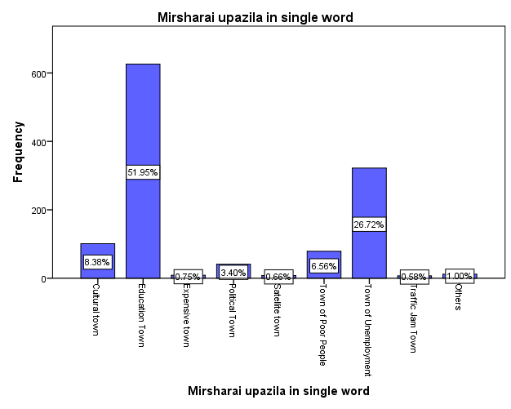Figure 4.14.4: Bar Diagram Showing the distribution
4.14.4: Mirsharai upazila in single ward: Among all the response 52% belongs to the Mirsharai as an Educational town because of some nameable educational institutions like Zorargonj Textile College, Mirsarai Degree College, Baroiyerhat Degree College et cetera. 26.7% respondents express that mirsharai is a town of unemployment due to high rate of unemployment. Political personnel like Engineer Mosharraf Hossain and Dilip Borua are prominent political person in MIrsharai, so that 3.4% respondents express Mirsharai
Table 4.14.5: Distribution of Mirsharai in Single Word
Mirsharai upazila in single word
Categories |  | Frequency |  | Percent |  | Valid Percent |  | Cumulative Percent
Cultural town |  | 101 |  | 8.4 |  | 8.4 |  | 8.4
Education Town |  | 626 |  | 52.0 |  | 52.0 |  | 60.3
Expensive town |  | 9 |  | .7 |  | .7 |  | 61.1
Political Town |  | 41 |  | 3.4 |  | 3.4 |  | 64.5
Satellite town |  | 8 |  | .7 |  | .7 |  | 65.1
Town of Poor People |  | 79 |  | 6.6 |  | 6.6 |  | 71.7
Town of Unemployment |  | 322 |  | 26.7 |  | 26.7 |  | 98.4
Traffic Jam Town |  | 7 |  | .6 |  | .6 |  | 99.0
Others |  | 12 |  | 1.0 |  | 1.0 |  | 100.0
Total | 1205 |  | 100.0 |  | 100.0
Source: Field Data

Other Surveys

Educational Survey
  - Name and Location of some prominent educational Institutes: In the Survey area educational institutions are categories into the School (Primary & Higher Secondary), College and Madrasha. In the Table 1.1, some prominent educational institutions are shown.
Table: 1.1: Name and Location of some prominent educational Institutes:
Name of Building | Location of Building
Purbo Bariakhali Govt. Primary School | Pubo Bariakhali, Katachora, Mirsorai
Korerhat K, M High School | Korerehat, Mirsorai
Nirudha Shundori Govt. Primary School | Durgapur
Habilder Basa United Academy | Habilderbasa, Korerhat
Zorargonj Ideal Academy | Zorargonj
Sunflower Grammer School | Shantir Hat, Mirsorai
Uttar Dhoom Dowlat Bibi Govt. Primary School | Uttar Dhoom, Mirsorai
Hinguli Moni Bibi Govt. Primary School | Mirsorai
Poshcim Zoar Govt. Primary School | Poshcim Zoar, Korerhat, Mirsorai
Zorargonj Ideal Academy | Zorargonj
Islampur Govt. Primary School | Islampur, Mirsorai
Foyzia Nacemul Ulum Madrashah and Yatimkhana | Poshcim Azompur, Mirsorai
Zorargonj Islamia Dakhil Madrashah | Zorargonj
Zobaida Islam Nurania Islamia Madrashah | Driver Hat, Mirsorai
Madinatul Ulum Hafezia Madrashah and Yatimkhana | Poshcim Zoar, Korerhat, Mirsorai
Textile Engineering College | Zorargonj
Chor Shorot Basimul-Ulum Talimul Madrasha & Yatimkhana | Bangla Bazar, Chor Shorot
Chor Shorot High School | Banglabazar, Chor Shorot
Zorargonj Girls High School | Zorargonj
Moulovi Nazir Ahmed Dakhil Madrasha | Zorargonj
Baraiyarhat College | Hinguli,MIrsharai
Hinguli Kodomtola Islamia Dakhil Madrasha | Hinguli, Kodomtola
Jamalpur Jinnat Bibi Govt. Primary School | Jamalpur
Source: Field Data

1.2: Statistics of the Educational Institution: In the Table 1.2, statistics of some of important information’s are shown. Total 122 educational institutions are consider in this study. Maximum area of instruction is 200(shotok) and minimum area is 3 (shotok), average land area is 39.64(shotok). Maximum number of student recorded is 3008, minimum is 20, and average number students in this survey is 348.99~349 per institution.
Table 1.2: Statistics of the Educational Institution
Statistic | Area  (Shotok) | Number of Student | Number of Teacher | Hostel Facilities | Transport Facilities | Number of Dropout Student  (primary) | Number of Dropout Student(Secondary) | Number of Dropout Student(Madrasha)
Valid | 122 | 122 | 122 | 118 | 117 | 43 | 28 | 44
Missing | 0 | 0 | 0 | 4 | 5 | 79 | 94 | 78
Mean | 39.64 | 348.99 | 10.06 | .79 | .79 | .88 | 2.64 | 1.86
Range | 197 | 2988 | 35 | 1 | 1 | 7 | 30 | 30
Minimum | 3 | 20 | 1 | 0 | 0 | 0 | 0 | 0
Maximum | 200 | 3008 | 36 | 1 | 1 | 7 | 30 | 30
Source: Field data
Average number of teacher in each institution is 10.06~10, where maximum number of teacher is 36 and minimum number teacher recorded is just 1.
1.3: Information of Educational Institution: In the Table 1.3, shows the maximum 37.7% are Madrasha having 46 in the count. 35.2% information of primary school and 22.1% about high school.
Table 1.3: Distribution of Educational Institution
Educational Institution | Frequency | Percent | Valid Percent | Cumulative Percent
Kindergarten | 2 | 1.6 | 1.6 | 1.6
Primary School | 43 | 35.2 | 35.2 | 36.9
High School | 27 | 22.1 | 22.1 | 59.0
Madrashah | 46 | 37.7 | 37.7 | 96.7
College | 4 | 3.3 | 3.3 | 100.0
Total | 122 | 100.0 | 100.0
Source: Field data
1.4: Hostel Facilities: In the Table1.4, 20.5% of the educational institutions have the hostel facilities, so that 76.2% of educational institution have no hostel facilities.
Table 1.4: Distribution of Hostel Facilities
Hostel Facilities |  | Frequency | Percent | Valid Percent | Cumulative Percent
Valid | Yes | 25 | 20.5 | 21.2 | 21.2
Valid | No | 93 | 76.2 | 78.8 | 100.0
Valid | Total | 118 | 96.7 | 100.0
Missing | System | 4 | 3.3
Total |  | 122 | 100.0
Source: Field data
1.5: Transport Facilities: Among the 5 Institution did not want to expose the information about the transport facilities out of 122 educational institutions. So, among the total valid information about 117, 19.7% of institutions, only have transport facilities beside the 76.2% have no transport facilities.
Table 1.5: Distribution of Transport Facilities
Transport Facilities |  | Frequency | Percent | Valid Percent | Cumulative Percent
Valid | Yes | 24 | 19.7 | 20.5 | 20.5
Valid | No | 93 | 76.2 | 79.5 | 100.0
Valid | Total | 117 | 95.9 | 100.0
Missing | System | 5 | 4.1
Total |  | 122 | 100.0
Source: Field data

1.6: Dropout Student (Primary): In the table 1.6, 33% of primary educational institutions have no record of the dropout students, no significant dropout recorded in this survey for primary institution,
Table: 1.6: Number of Dropout Student (Primary):
Number of Dropout Student(primary) |  | Frequency | Percent | Valid Percent | Cumulative Percent
Valid | No | 33 | 27.0 | 76.7 | 76.7
Valid | 1 | 2 | 1.6 | 4.7 | 81.4
Valid | 2 | 1 | .8 | 2.3 | 83.7
Valid | 3 | 2 | 1.6 | 4.7 | 88.4
Valid | 5 | 3 | 2.5 | 7.0 | 95.3
Valid | 6 | 1 | .8 | 2.3 | 97.7
Valid | 7 | 1 | .8 | 2.3 | 100.0
Valid | Total | 43 | 35.2 | 100.0
Missing | System | 79 | 64.8
Total |  | 122 | 100.0
Source: Field data
Table: 1.7: Number of Dropout Student (Secondary):
Number of Dropout Student(Secondary) |  | Frequency | Percent | Valid Percent | Cumulative Percent
Valid | No | 14 | 11.5 | 50.0 | 50.0
Valid | 1 | 3 | 2.5 | 10.7 | 60.7
Valid | 2 | 4 | 3.3 | 14.3 | 75.0
Valid | 5 | 5 | 4.1 | 17.9 | 92.9
Valid | 8 | 1 | .8 | 3.6 | 96.4
Valid | 30 | 1 | .8 | 3.6 | 100.0
Valid | Total | 28 | 23.0 | 100.0
Missing | System | 94 | 77.0
Total |  | 122 | 100.0
Source: Field data

Table: 1.8: Number of Dropout Student (Secondary):
Number of Dropout Student(Madrasha) |  | Frequency | Percent | Valid Percent | Cumulative Percent
Valid | No | 32 | 26.2 | 72.7 | 72.7
Valid | 2 | 3 | 2.5 | 6.8 | 79.5
Valid | 3 | 1 | .8 | 2.3 | 81.8
Valid | 4 | 1 | .8 | 2.3 | 84.1
Valid | 5 | 3 | 2.5 | 6.8 | 90.9
Valid | 6 | 1 | .8 | 2.3 | 93.2
Valid | 8 | 1 | .8 | 2.3 | 95.5
Valid | 10 | 1 | .8 | 2.3 | 97.7
Valid | 30 | 1 | .8 | 2.3 | 100.0
Valid | Total | 44 | 36.1 | 100.0
Missing | System | 78 | 63.9
Total |  | 122 | 100.0
Source: Field data

Environmental Survey
Waste management is the most important factor to keep the environment clean. The process of waste management is a very functional because it started its work in morning by collecting of waste, bring to it into the disposal place and at the end dispose the waste.
Here waste management information of the two important area Mirsharai and Baroihat.
Table 1.1: Waste management information about Baraiyarhat Municipality
Dustbin | Waste collection vehicles |  |  | Dumping Station
Dustbin | Van | Truck | Garbage Truck | Dumping Station
131 | 6 | 3 | 1 | 2
Source: Baroihat Municipality
Information about the Dumping Stations:
Location | Area
Near the Baraiyarhat College | 20 Shotok
Near the Baraiyarhat Micro Bus stand | 50 Shotok

In the Baroihat Municipality collect waste regularly.
Table1.2: Waste management information about Mirsharai Municipality
Dustbin | Waste collection vehicles |  |  | Dumping Station
Dustbin | Van |  | Garbage Truck | Dumping Station
150 | 4 |  | 2 | 1
Source: Field data

Information about the Dumping Station:
Location | Area
Near the Post office Disposal Station | 50 Shotok
Source: Field data
1.3: Noise Level: Noise collected from the different places in the survey area, list of recorded data of noise is presented below with maximum, minimum and average noise level in the specific area.
Table1.3: Noise Level in the survey area:
Places/Points | Maximum(dB) | Minimum(dB) | Average(dB)
College Road , Mirsharai | 72 | 44 | 54
Mirsharai Over bridge | 79 | 43 | 56
Mirsharai Police Station Area | 75 | 52 | 49
Stadium Gate | 77 | 50 | 58
Mohamaya Lake(Boat Ghat) | 74 | 29 | 45
Mohamaya Lake | 63 | 33 | 45
Beribadh(Dam) | 73 | 29 | 48
North Hill Area | 73 | 39 | 48
Sluice Gate | 81 | 50 | 69
Baroihat(Bus Stand) | 89 | 67 | 80
Baroihat(Rail Gate) | 87 | 63 | 73
Baroihat(Rail gate with moving train) | 90 | 64 | 75
Source: Field survey

Figure 1.4: Bar diagram of Noise Level in the survey area
1.5: Waste Collection Schedule in the survey area: In the Table 1.5, shows that the 47.5% waste collection is done by daily. But 42.1% have no schedule for collecting the waste.
Table1.5: Waste collection Schedule:
Waste collection/cleaning schedule
schedule | Frequency | Percent | Valid Percent | Cumulative Percent
Daily | 327 | 47.5 | 47.5 | 47.5
Irregular | 290 | 42.1 | 42.1 | 89.6
Once in Week | 28 | 4.1 | 4.1 | 93.6
Twice in a Week | 44 | 6.4 | 6.4 | 100.0
Total | 689 | 100.0 | 100.0

1.6: Dustbin distance from house: In the Table4.2, 52.5% of the dustbin distance within the 50 meters. Other two categories rest of the percentages in the survey.
Table 1.6: Dustbin distance from house (if available) (m)
Distances | Frequency | Percent | Valid Percent | Cumulative Percent
<50 | 362 | 52.5 | 89.2 | 89.2
50-100 | 19 | 2.8 | 4.7 | 93.8
100-150 | 25 | 3.6 | 6.2 | 100.0
Total | 406 | 58.9 | 100.0
Source: Field data
Table 1.7: Dustbin distance from house (if available) (m)
Categories | Frequency | Percent | Valid Percent | Cumulative Percent
Yes | 212 | 30.8 | 30.8 | 30.8
No | 477 | 69.2 | 69.2 | 100.0
Total | 689 | 100.0 | 100.0
Source: Field data
Table 1.8: Waste disposal Schedule
Schedule | Frequency | Percent | Valid Percent | Cumulative Percent
Daily | 276 | 40.1 | 40.1 | 40.1
Irregular | 381 | 55.3 | 55.3 | 95.4
Once in a week | 32 | 4.6 | 4.6 | 100.0
Total | 689 | 100.0 | 100.0
Source: Field data

Health Facilities
In the health survey, we have observed 20 healthcare centre in the survey area, among them we were trying to include all types’ healthcare centres. In this survey, we have included government health care as well private clinic, homio hall, Diagnostic centre, Dental Clinic et cetera.
Table1.1: Name and Location of the health centre:
Name of Health Facilities Centre | Location
Modern Homio & Clinic | Mannan Bhobon, Baraiyarhat
Bismillah Dental Care | Mannan Bhobon, Baraiyarhat
Bijoy Community Eye Hospital | Al-Fatah City Center, Zorargonj
Baraiyarhat General Hospital | Old D T Road, Baraiyarhat
Popular Lab. & Diabetic Centre | Haowa Bhobon, Zorargonj
Baraiyarhat Eye Hospital | North Bus Stand, Baraiyarhat
Jononi Clinical Lab. | Jamalpur Super Market, Baraiyarhat
Bijoy Dental Clinic | North Bus Stand, Baraiyarhat
Niharika Homio Hall | Jamalpur Super Market, Baraiyarhat
Medipath Diagnostic Center | Haji Abul Bashar Market, Baraiyarhat
Shefa Insan Hospital & Diagnostic | North Sonapahar, Baraiyarhat
Ebadat Dental Care | Jomidar Plaza, Baraiyarhat
Nur Dental Care | Majeda Building, Baraiyarhat
Jahan Detal Care | Al-Amin Shoping Center,Baraiyarhat
Mediscan Ltd. Diagnostic Center | Al-Amin Shoping Center,Baraiyarhat
Ensure Medilab | Al-Amin Shoping Center,Baraiyarhat
Baraiyarhat Physiotherapy & Dental Care | Abu Usama Super Market,Baraiyarhat
Dr. Salauddin Dental Care | Abu Usama Super Market,Baraiyarhat
Rajonigondha Diagnostic Center | Baraiyarhat
Baraiyarhat Municipality Health & Family Care Center | Jamalpur
Source: Field data

1.2: Bed Facilities: In the Table 1.2, 85% of the healthcare centre have no bed facilities, one healthcare centre have just one bed, and 2 healthcare centre have 20 beds facilities.
Table1.2: Bed Facilities of the Healthcare Centre:
Number of Bed | Frequency | Percent | Valid Percent | Cumulative Percent
No Bed | 17 | 85.0 | 85.0 | 85.0
1 | 1 | 5.0 | 5.0 | 90.0
20 | 2 | 10.0 | 10.0 | 100.0
Total | 20 | 100.0 | 100.0
Source: Field data
1.3: Doctors (permanent) in the Healthcare Centre: In the Table1.3, 45% of the healthcare centre have only one permanent doctor, 20% have two permanent doctors. In this survey among all the healthcare centre 20% healthcare centre have no permanent doctors.
Table1.3: Number of Doctor (permanent) in the Health Centre:
Number of Doctor(permanent) | Frequency | Percent | Valid Percent | Cumulative Percent
No Doctor | 4 | 20.0 | 20.0 | 20.0
1 | 9 | 45.0 | 45.0 | 65.0
2 | 4 | 20.0 | 20.0 | 85.0
3 | 1 | 5.0 | 5.0 | 90.0
4 | 2 | 10.0 | 10.0 | 100.0
Total | 20 | 100.0 | 100.0
Source: Field data

1.4: Permanent Nurse: In the Table 1.4, shows that the 70% of the healthcare centre have no Permanent nurse, Maximum number of the nurses only in the one healthcare centre, having 12 permanent nurses.
Table1.4: Number of Nurse (permanent) in the Health Centre:
Nurse(permanent) | Frequency | Percent | Valid Percent | Cumulative Percent
No Nurse | 14 | 70.0 | 70.0 | 70.0
1 | 1 | 5.0 | 5.0 | 75.0
2 | 1 | 5.0 | 5.0 | 80.0
4 | 1 | 5.0 | 5.0 | 85.0
5 | 1 | 5.0 | 5.0 | 90.0
9 | 1 | 5.0 | 5.0 | 95.0
12 | 1 | 5.0 | 5.0 | 100.0
Total | 20 | 100.0 | 100.0
Source: Field data
Table1.5: Number of Doctor (Consultant) in Healthcare Centre:
Doctor(Consultant) | Frequency | Percent | Valid Percent | Cumulative Percent
No Doctor(Consultant) | 6 | 30.0 | 30.0 | 30.0
1 | 7 | 35.0 | 35.0 | 65.0
2 | 1 | 5.0 | 5.0 | 70.0
3 | 2 | 10.0 | 10.0 | 80.0
7 | 1 | 5.0 | 5.0 | 85.0
9 | 1 | 5.0 | 5.0 | 90.0
10 | 1 | 5.0 | 5.0 | 95.0
11 | 1 | 5.0 | 5.0 | 100.0
Total | 20 | 100.0 | 100.0
Source: Field data
1.6: Working Hour Doctor (Consultant):
Table1.6: Working Hour of Doctor (Consultant) in the Healthcare Centre:
Working Hours |  | Frequency | Percent | Valid Percent | Cumulative Percent
Valid | 2 Hours | 1 | 5.0 | 7.1 | 7.1
Valid | 3 Hours | 2 | 10.0 | 14.3 | 21.4
Valid | 4 Hours | 1 | 5.0 | 7.1 | 28.6
Valid | 5 Hours | 5 | 25.0 | 35.7 | 64.3
Valid | 6 Hours | 3 | 15.0 | 21.4 | 85.7
Valid | 7 Hours | 1 | 5.0 | 7.1 | 92.9
Valid | 9 Hours | 1 | 5.0 | 7.1 | 100.0
Valid | Total | 14 | 70.0 | 100.0
Missing | System | 6 | 30.0
Total |  | 20 | 100.0
Source: Field data
Table1.7: Statistics of Healthcare Centre:
Statistic |  | Number of Bed | Number of Doctor  (permanent) | Number of Nurse  (permanent) | Number of Doctor  (Consultant) | Working Hour
Number | Valid | 20 | 20 | 20 | 20 | 14
Number | Missing | 0 | 0 | 0 | 0 | 6
Average |  | 2.05 | 1.40 | 1.65 | 2.60 | 5.07
Range |  | 20 | 4 | 12 | 11 | 7
Minimum |  | 0 | 0 | 0 | 0 | 2
Maximum |  | 20 | 4 | 12 | 11 | 9
Source: Field data

Industry Survey
1 Basic Information: Some important industry name and location in the survey area, which are surveyed in details for the other survey study.
Table1.1: Name of industry and Location
Name of the Industry | Location
M.E.A.S Bricks field | Purbo Hinguli, Mirsorai
Baro Awlia Bread Factory | Vogobotipur, Mirsorai
Eco Block Fa | Dhoom Ghat, Mirsorai
Cotton Factory | Chairman Road,
C.P Bangladesh company ltd. | Sadarmadighi, Mirsorai
Precast Pipe Factory | Gortakia, Mirsorai
Abu Taher Sawmill | Korerhat, Mirsorai
Amir Hosen Sowmill | Shantirhat, Mirsorai
Chowdhari Bricks Field | Purbo Raypur, Mirsorai
S. B. K Bricks Field | Korerhat, Mirsorai
Kaium Sowmill | Shantirhat, Mirsorai
Hazi Abu Taher Sowmill | Shantirhat, Mirsorai
Janota Sowmill | Shantirhat, Mirsorai
Rahim Sowmill | Baroiyarhat, Mirsorai
Ruhul Ameen Sowmill | Shantirhat, Mirsorai
Hazi Delower Oil Mill | Shantirhat, Mirsorai
Nadia Sowmill | Shantirhat, Mirsorai

Table1.2: Industry Type (Formal/Informal)
Categories | Frequency | Percent | Valid Percent | Cumulative Percent
Formal | 5 | 29.4 | 29.4 | 29.4
Informal | 12 | 70.6 | 70.6 | 100.0
Total | 17 | 100.0 | 100.0
Source: Field data
In the table1.2, total number of formal industries are 29.4% and, 70.6% are informal industry in the survey area.
Table1.3: Distribution of Finance
Classes | Frequency | Percent | Valid Percent | Cumulative Percent
Self | 13 | 76.5 | 76.5 | 76.5
Loan | 1 | 5.9 | 5.9 | 82.4
Joint venture | 3 | 17.6 | 17.6 | 100.0
Total | 17 | 100.0 | 100.0
Source: Field data
In the Table1.3, there is 76% of industries are financed by the owner of the industry, 17.6% industry run by a joint venture.

1.4. Input (Raw Materials): Different types of raw materials needed for the different types industry. In the survey area, we have found that some different types of industries.
Table 1.4: Input items of different industries
Industry Type | Input Items | Sources
Brick Field | Soil | Local Area
Brick Field | Coal | Sylhet, India
Brick Field | Diesel | Diesel
Saw Mill | Wood | Local/Forest Area
Pipe Factory | Stone | Sylhet
Pipe Factory | Rod | BSRM Steel Factory
Pipe Factory | Sand | Dhumghat
Bread Factory | Flour | Mirsharai
Bread Factory | Sugar | Zorargonj
Bread Factory | Oil | Zorargonj

Bank, Insurance and Shop Survey
1.1 Some Formal Structure in the Survey Area: A formal organization is a fixed set of rules of intra-organization procedures and structures. As such, it is usually set out in writing, with a language of rules that ostensibly leave little discretion for interpretation.
Table 1.1: Formal Structures in the survey area:
Rice
Pulses
Vegetable
Source: Field data

1.2 Total number of labour in the formal sector in the survey area: The majority of the formal structure are Bank, Which having maximum number of labourers.

Fgure1.2 Total number of labour in the formal sector in the survey area

Table 1.3: Informal Structures in the survey area:
Name | Structure Type | Type
Vat Ghor | Tin Shed | Restaurant
Mayer Doa Hotel & Restaurant | Semi Pucca | Restaurant
Kashbon Hotel & Restaurant | Pucca | Restaurant
Madina Jewellers | Pucca | Jewellery
Laki Fashion Moll | Pucca | Cloth Store
Shuvecca Cloth & Garments | Pucca | Cloth Store
Zamal Tea Stall | Semi Pucca | Tea Stall
Nurul Huda Tea Stall | Semi Pucca | Tea Stall
Ahmmed Traders | Pucca | Building Material
Antorongo Cloth & Garments | Pucca | Cloth Store
Moulana Varsities | Semi Pucca | Home Accessories
Sneha Media | Semi Pucca | Photocopy, Print, Studio
New Alamin Store | Tin Shed | Grocery store
Khan Saheb Hotel | Semi Pucca | Restaurant
Haji Design Furniture | Semi Pucca | Furniture Shop
Rima Medical Hall | Pucca | Pharmacy
Vaiya Variety Store | Semi Pucca | Grocery store
Zoynal Tea Store | Pucca | Tea Stall
Gopal Store | Tin Shed | Pan Store
Forhad Hotel | Semi Pucca | Restaurant
Popular Pharmacy | Pucca | Pharmacy

Figure1.2: Bar diagram of Informal Structures in the survey area
1.3 Transaction per day (Informal):
Figure1.3: Bar diagram of transaction per day by shop category.
Figure1.4: Bar diagram of number of customer per day

Table1.5: Number of labor in the informal shop
Number of Labor | Frequency | Percent | Valid Percent | Cumulative Percent
1 | 22 | 39.3 | 39.3 | 39.3
2 | 8 | 14.3 | 14.3 | 53.6
3 | 6 | 10.7 | 10.7 | 64.3
4 | 6 | 10.7 | 10.7 | 75.0
5 | 7 | 12.5 | 12.5 | 87.5
6 | 1 | 1.8 | 1.8 | 89.3
7 | 3 | 5.4 | 5.4 | 94.6
9 | 1 | 1.8 | 1.8 | 96.4
15 | 2 | 3.6 | 3.6 | 100.0
Total | 56 | 100.0 | 100.0
Source: Field Data
Agricultural Survey
1.1 Average Productions in the Unions: Figure1.1: Bar Diagram of average production

1.2 Average Market Price of the Products:
Figure1.1: Bar Diagram of average Local Market Price of production

Archaeological Survey
Table 1.1:
Name of the Archaeological Building | History(Attached) | Location | Year of Construction
Moghadia Chowdhury Bari jame Moshjid | Owasil Chowdhury was the founder of the Mosque. | Moghadia | 1857(Est.)
Kenu Jomidar Bari/Moghadia Jomidar Bari | Owasil Chowdhury was the founder of the Building. | Middle Moghadia, Mirsharai | 1857(Est.)
Amanullah Bhuiya Bari Jame Moshjid | Jomidar Haji sultan was the Founder of the Mosque | Middle Mithanala, Mirsharai | 1800(Est.)
Jomidar Oakil Chowdhury | Owaris Md. Owakil Chowdhury was Built the Jame Moshjid | Minal, Mithanala, Mirsharai | 1600(Est.)
Sheikh Tola Hamidullah khan Jame Moshjid | The mosque was built by Mughal Subadar Shaista Khan in the name of his father | Sheikh Tola,Moghadia, Mirsharai | 1670(Est.)
Poragolpur Boro Jame Moshjid | The mosque was built by Chutika jomidar | Poragolpur,Mirsharai | 1800(Est.)
Shamshan Mondir | It was built in 1936 by Jomindar Romoni Mohon Chowdhury to perform the cremation for his parents, | West Maliyas, Mithanala, Mirsharai | 1936(Est.)
Building(Unknown) | It was built by Jomindar Romoni Mohon Chowdhury for living | West Maliyas, Mithanala, Mirsharai | 1936(Est.)
Chowdhury Bari Kachari Ghor | Kachari Ghor | Naherpur Chowdhury Bari | 1930(Est.)
Mohammad Mukim Chowdhury Moshjhid | It was built in 1780 by Mohammad Mukim Chowdhury | Dhoom,Mohajon Hat, Mirsharai | 1780(Est.)
Kocua Sheikher Taluk Moshjid |  | Sheikher Taluk, Mirsharai | 1800(Est.)

Table1.2:
Name  of  the Archaeological Building | Attached Facilities | Maintenance |  | Archaeological Preservation Conservation
Name  of  the Archaeological Building | Attached Facilities | No. of Staff | Staff Type | Yes/No | If Yes
Moghadia Chowdhury Bari jame Moshjid | Electricity |  |  | No
Kenu Jomidar Bari/Moghadia Jomidar Bari | Nothing | 2 | Caretaker | No
Amanullah Bhuiya Bari Jame Moshjid | Electricity | 4 | Muajjin, Imam, Khatib | No
Jomidar Oakil Chowdhury | Electricity,Solar Enargy, IPS | 2 | Imam, Muajjin | No
Sheikh Tola Hamidullah khan Jame Moshjid | Electricity | 2 | Imam, Muajjin | No
Poragolpur Boro Jame Moshjid | Electricity | 2 | Imam, Muajjin | No
Shamshan Mondir |  |  |  | No
Building(Unknown) | Electricity |  |  | No
Chowdhury Bari Kachari Ghor | Electricity | 1 | Gateman | No
Mohammad Mukim Chowdhury Moshjhid | Electricity | 3 | Imam, Muajjin | No
Kocua Sheikher Taluk Moshjid | Electricity | 3 | Imam, Muajjin | No

CHAPTER FIVE

Conclusion: In the survey, we have found out some socioeconomic factors which are directly related to the socioeconomic status of the survey are.
In the Mirsharai Upazilla, we have found out the 53.3%of the male respondent and 44.7% of the female respondents.
In the report, we find out the 23.3% residents are illiterate and 6% of total residents are highly educated.
Because of most of the female respondent responses about their occupations as housewife, so that in the report maximum percentages (39.5%) of occupation is a housewife. Maximum number of family type in the survey is single type, which contains 72.2% of the total percentages, and family members at the age range 05-09 contains maximum 53.2% in the count.
Religion distribution in mainly Muslim 85%, Hindu 13.8% and Buddhist has 1.2% in the survey area. We find out 37 autism cases in the survey area, where maximum 33 cases having Autistic Disorder/Classic Autism, and other autism types are Asperger Syndrome and Pervasive Developmental Disorder.
In the report, 36% of the resident have earned less than TK5, 000 per month in the survey area, and only 2.8% have earned more than TK50000 per month in the survey area. 40.2% of the resident staying outside the country temporarily among total residents who have been staying outside the survey area.
Drinkable water is available here, 88.8% water is drinkable, and 93.0% water sources have arsenic contamination. Khaiyachora and Mohamaya Lake are two most favourite travel destination across the country situated in this area.
In the education survey student dropout is not in big numbers, but transport and hostel facilities are not impressive in this area. Municipalities are trying to collect and dispose waste properly. Some of the area like hill tracts and lakes have standard noise level (70dB), but others area are not.

